1. ***Listen to the text about Australia and fill in missing words***

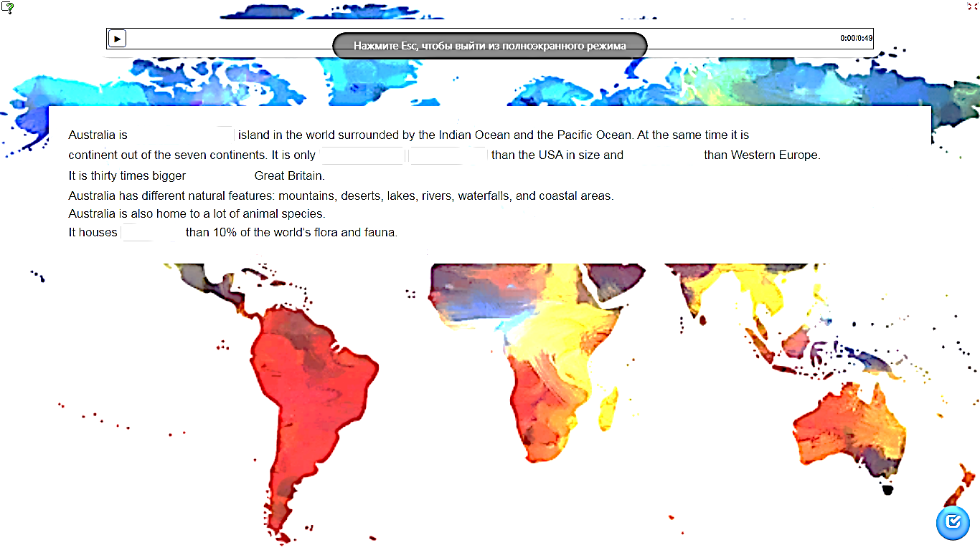

*Words: the biggest, smallest, bigger, a little smaller, than, more*

1. **Watch the video about China and answer: True or False**

1. China is a country in Europe  
2. The official language is Chinese mandarin  
3. Elephants are very important to Chinese culture and art  
4. Giant pandas and pink dolphins live in China   
5. There is the Great wall in China

1. ***Do the quiz about the UK***

**1. What is the capital of the United Kingdom?**

a) Edinburg b) London c) Cardiff

**3. What animals live in the UK?**

a) Dolphins b) Pandas c) Deer

**4. What is the Big Ben?**

a) a tower b) a clock c) a bell

**5. What is the official language in Great Britain?**

a) Scottish b) English c) Russian

1. **Fill in the table about Russia**

|  |  |  |  |
| --- | --- | --- | --- |
| **Capital** | **Language** | **Animals** | **Interesting fact or place** |
|  |  |  |  |